OPPORTUNITY | DISPLAYED | GIFT MINIMUM | SUPPORTS
BRONZE BENCH PLAQUE (Exterior – Multiple remaining) | Along the backrest of the new bench on porch outside the High Peaks Information Center  Plaque is 5” by 2”  Select Image (none, ADK logo, animal paw, backpack, bicycle, compass, skis or wildflower)  Three lines of text (24 characters each) | $500 | Annual Fund
BRONZE BENCH PLAQUE (Interior – Three remaining) | On the log benches placed inside the High Peaks Information Center  Plaque is 5” by 2”  Select Image (none, ADK logo, animal paw, backpack, bicycle, compass, skis or wildflower)  Three lines of text (24 characters each) | $500 | Annual Fund
MAP TABLE  (Interior – One available) | On the side of the map table placed inside the High Peaks Information Center  Plaque is 5” by 2”  Select Image (none, ADK logo, animal paw, backpack, bicycle, compass, skis or wildflower)  Three lines of text (24 characters each) | $1,000 | Annual Fund
ADIRONDACK CHAIRS  (Exterior – Ten remaining) | Plaque on back side of chair (not on the back of the seat)  Plaque is 5” by 7”  Four lines of text (24 characters each) | $1,000 | Annual Fund
STOVE  (Interior – One available) | On the hearth near the propane stove  Plaque is 5” by 7”  Four lines of text (24 characters each) | $5,000 | Annual Fund
BRIDGE FROM PARKING LOT  (Exterior – One available) | On the bridge railing of the new bridge over the swale leading from the lot to the High Peaks Information Center  Plaque is 5” by 7”  Four lines of text (24 characters each) | $10,000 | Annual Fund
FRONT DECK  (Exterior – One available) | On the exterior wall of HPIC along the porch  Plaque is 5” by 7”  Four lines of text (24 characters each) | $25,000 | Annual Fund

Your generous donation will be applied to the annual fund unless otherwise specified or agreed. In supporting the annual fund, your gift will be used where the need is greatest at the time of your donation.
A note about the lifespan of your named item and your plaque:
Plaques will be ordered following the successful completion of your pledge and will remain on display throughout the lifespan of the naming opportunity you selected.
Exterior items (benches, chairs, bridges and other structures) must weather Adirondack winters and other conditions. ADK will repair and maintain the item as long as practicable but will eventually need to replace or stop using the item.
ADK reserves the right to maintain, replace, move, or otherwise alter a plaque or its display. We will do so in keeping with the intent of your gift. In the event that we replace or stop using the item, we will move your plaque to a new location on the same property.

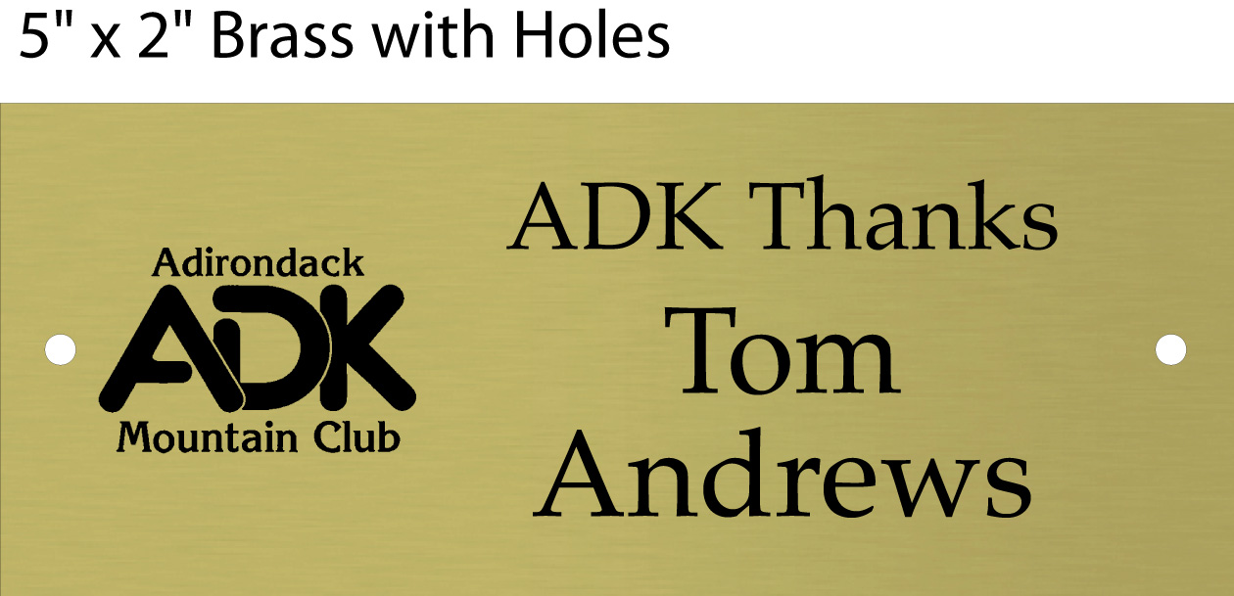
Plaque Order Form
Name:
My naming opportunity is a:
BRONZE BENCH PLAQUE - Exterior BRONZE BENCH PLAQUE - Interior
My bronze plaque is 5” by 2” I prefer: No Image
Or, select one:
ADK logo Animal paw print Backpack Bicycle Compass directions
Skis Wildflower
Please note, each line has up to 24 characters. Include any punctuation and spaces.
My plaque will read:
Line 1 _ _ _ _ _ _ _ _ _ _ _ _ _ _ _ _ _ _ _ _ _ _ _ _
Line 2 _ _ _ _ _ _ _ _ _ _ _ _ _ _ _ _ _ _ _ _ _ _ _ _
Line 3 _ _ _ _ _ _ _ _ _ _ _ _ _ _ _ _ _ _ _ _ _ _ _ _

My naming opportunity is a:
ADIRONDACK CHAIR MAP TABLE STOVE BRIDGE FROM PARKING LOT FRONT DECK
My bronze plaque is 5” by 7”
Please note, each line has up to 24 characters. Include any punctuation and spaces.
My plaque will read:
Line 1 _ _ _ _ _ _ _ _ _ _ _ _ _ _ _ _ _ _ _ _ _ _ _ _
Line 2 _ _ _ _ _ _ _ _ _ _ _ _ _ _ _ _ _ _ _ _ _ _ _ _
Line 3 _ _ _ _ _ _ _ _ _ _ _ _ _ _ _ _ _ _ _ _ _ _ _ _
Line 4 _ _ _ _ _ _ _ _ _ _ _ _ _ _ _ _ _ _ _ _ _ _ _ _
Notes:

